Sri Lanka Institute of Information

Technology

Lab Submission

08

**IT24100647**

**A.J.M.P.N.Jayasekara**

**Probability and Statistics | IT2120**

B.Sc. (Hons) in Information Technology

**Exercise**

1. 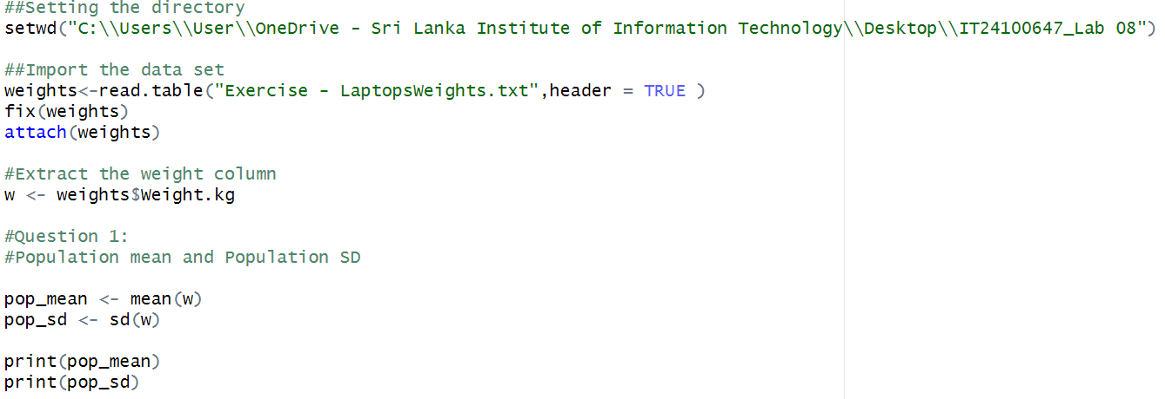Calculate the population mean and population standard deviation of the laptop bag weights.

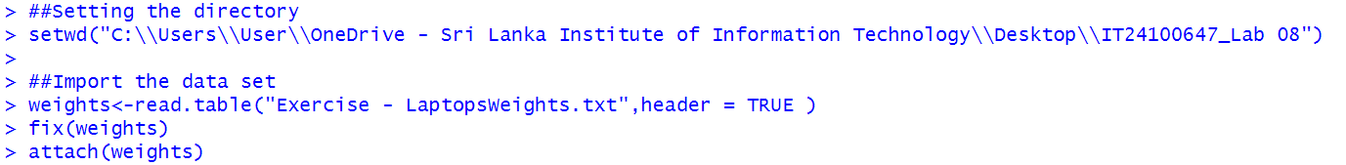

2. Draw 25 random samples of size 6 (with replacement) and calculate the sample mean and sample standard deviation for each sample.

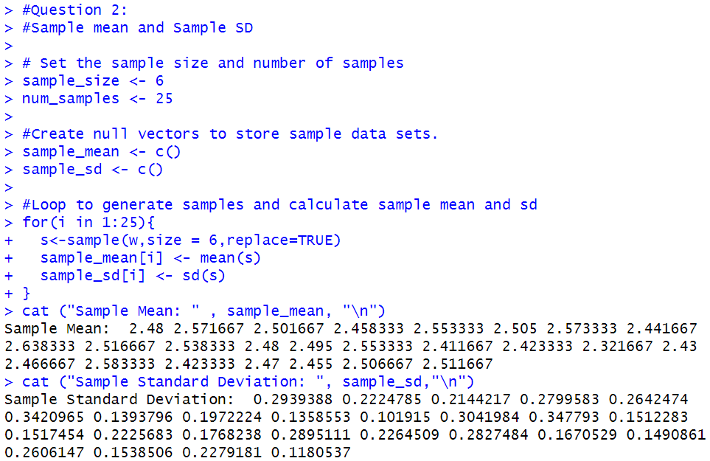

3. Calculate the mean and standard deviation of the 25 sample means and state the relationship of them with true mean and true standard deviation.

